HAYHOE’S BBQ STREETVAULT
Saturday, July 21st, 2007

MEET INFORMATION

1. Location: Jeff Hayhoe’s Street
219 Edward Pottage Crescent, RR 2
Pottageville, ON L0G 1T0

2. Eligibility: Open to athletes of all ages.
*NEW HIGH SCHOOL SECTION FOR 2007*

3. Entry Fee: Entry fee is 30$ for OTFA and USATF members and 35$ for non registered athletes. It includes a bottle of Gatorade and a hamburger or hotdog.

4. Entry Deadline: Entries must be submitted by Saturday July 14th 2007 via email. Please email your name, age, personal best and whether you are an OTFA member or a member of another association. Email entries to John Zubyck at zuber25@hotmail.com.

5. Prizes: PRIZES WILL BE AWARDED TO EACH FLIGHT
*Guaranteed Cash Prize of 125$ to first place in the men and women’s Elite sections*
Other Prizes to be announced later!
6. Refreshments: There will be a BBQ occurring throughout the competition. Hot dogs, hamburgers, pop and water will be sold.

7. Seating: Vaulters and fans are asked to bring lawn chairs and or blankets as there will be no seating arrangements.

8. Parking: Parking will be available on Edward Pottage Crescent. Please park accordingly because we will be in a residential area and we do not want to upset surrounding neighbors. Please try to car pool so that we can accommodate for everyone’s parking needs.

9. Directions: Traveling on the 401 take highway 400 North. Exit on Loydtown/Aurora Road and take a left. Turn right on Edward Pottage Crescent (2 miles from 400). You’ll see it from there!

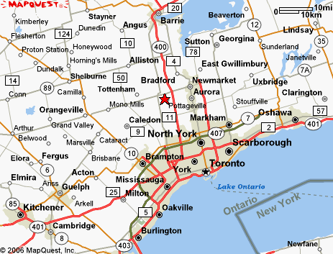

Entry Form

Name_____________________________________

Club______________________________________

OTFA # ___________________________________

SANCTIONED AND REQUIRED BY:
THE ONTARIO TRACK & FIELD ASSOCIATION
RELEASE, WAIVER AND INDEMNITY

IN CONSIDERATION of the acceptance of my application and the permission to participate as an entrant or competitor in the
2007 HAYHOE BBQ STREETVAULT
Saturday July 21st

I, for myself, my heirs, executors, administrators, successors and assigns HEREBY RELEASE, WAIVE AND FOREVER DISCHARGE

Ontario Track and Field Association
Town of Pottageville
John Zubyck & Jeff Hayhoe

and all other associations, sanctioning bodies and sponsoring companies, and all their respective agents, officials, servants, contractors, representatives, successors and assigns OF AND FROM ALL claims, demands, damages, costs, expenses, actions and causes of action, whether in law

or

equity, in respect of death, injury, loss or damage to my person or property HOWSOEVER CAUSED, arising or to arise by reason or my participation in the said event, whether as a spectator, participant, competition or otherwise, whether prior to, during or subsequent to the event AND NOTWITHSTANDING that same may have been contributed to or occasioned by the negligence of any of the aforesaid.

I FURTHER HEREBY UNDERTAKE to HOLD AND SAVE HARMLESS AND AGREE TO INDEMNIFY all of the aforesaid from and against any and all liability incurred by any or all of them arising as a result of, or in any way connected with my participation in the said event.

BY SUBMITTING this ENTRY, I ACKNOWLEDGE HAVING READ, UNDERSTOOD AND AGREED to the above WAIVER, RELEASE AND INDEMNITY. I WARRANT that I am physically fit to participate in this event.

_____________________________________________________________________________
Date Print Name Signature(if under 18 years, Parent or Guardian or Power of Attorney to sign below)

_____________________________________________________________________________
Date Print Name Signature of Legal Guardian

